

Topic test 1
Name: __________________________________

Chapter 9: Derivatives

• Time allowed: 45 minutes
• CAS calculators may be used.
• Part A: 5 multiple-choice questions (5 marks)
• Part B: 6 short answer questions (19 marks)
• Part C: 2 analysis questions (8 marks)
Part A
5 multiple-choice questions
1 mark each: 5 marks
Circle the correct answer.
1 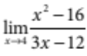 =
A 0
B
C
D
E none of the above

[1 mark]
2 The derivative function of f(x) = 4x³ has the rule
A f ʹ(x) = 4x²
B f ʹ(x) = 4x⁴
C f ʹ(x) = 24x
D f ʹ(x) = 12x
E f ʹ(x) = 12x²

[1 mark]

3 The derivative of y = 22x³ using first principles can be found by.
A f ʹ(x) = 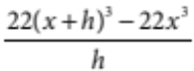
B f ʹ(x) = 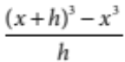
C f ʹ(x) = 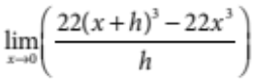
D f ʹ(x) = 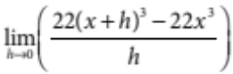
E f ʹ(x) = 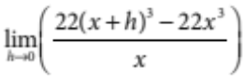

[1 mark]
4 The equation of the tangent to the graph of y = x² at the point (a, a²) is
A y = 2a²x + a
B y = 2ax − a²
C y = −2a²x + a
D y = ax
E y = 2x + a

[1 mark]
5 The temperature of a heating steel alloy is given by the equation T = 2t², where T is the temperature in °C and time is in t seconds. The instantaneous rate of change in temperature at t = 4 is:
A 16°C/sec
B 32°C/sec
C 8°C/sec
D 30°C/sec
E 40°C/sec

[1 mark]

Part B
6 short answer questions
19 marks
Show your working where appropriate.
1 For the function f(x) = 10x² + 3x + 1
a find f(2)

b find f(2 + h)

c find the gradient of the secant between the point where x = 2 and x = 2 + h

d hence, choose appropriate values for h to find f ʹ(2).

[4 marks]
2 P(x, y) and Q(x + h, y + k) are two points on the curve with equation f(x) = 11x².
a Find the gradient of PQ.

b Hence, find the gradient of the tangent at P.

[3 marks]
3 A model helicopter is flown so that it its height above the ground is given by h = 3t² at t seconds after it leaves the ground, where the height is in metres. Find each of the following.
a Its height after 3 seconds.

b Its velocity after 3 seconds.

[3 marks]

4 Let f(x) = 2x⁶. Find
a f ʹ(3)

b x such that f ʹ(x) = −3

[3 marks]
5 If the curve y = ax² has a gradient of 1 at the point (2, 1), find a.

[2 marks]
6 Let 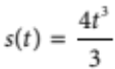 be the displacement function of a particle moving in a straight line, where t is in seconds and s is in metres. Find the acceleration when the velocity is 1.

[4 marks]

Part C
2 analysis questions
8 marks
Show your working where appropriate.
1 The cost, in tens of thousands of dollars, of airing x television commercials during an AFL football game is given by C(x) = 0.6x². Find:
a the exact cost of airing 5 commercials during an AFL football game.

b the average cost of airing the first 5 commercials.

c the marginal cost function and use it to find how fast the cost is increasing when x = 5.

[4 marks]
2 A cyclist spends 2 hours cycling from the foothills of the Great Dividing Range to Lake Eppalock. The ride can be described in three stages:
Stage 1: He rides at a constant speed of 20 km/h for 45 minutes.
Stage 2: He rides at a constant speed of 15 km/h for 45 minutes.
Stage 3: He rides at a constant speed of 25 km/h for 30 minutes.
Draw a distance–time graph that illustrates this motion.

[4 marks]
Total marks: 32

Answers
Part A [1 mark each]
1 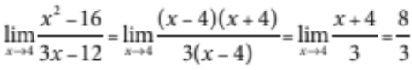
∴ D [1 mark]
2 Using the rule for finding the derivative of a polynomial:
f(x) = 4x³ ⇒ f ʹ(x) = 3 × 4x^{3 – 1} = 12x²
∴ E [1 mark]
3 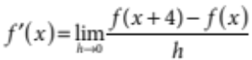
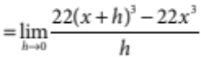
∴ D [1 mark]
4 The derivative of the function is yʹ = 2x. At the point (a, a²), the tangent has gradient 2a. The equation of the tangent in point slope form is:
y – a² = 2a(x − a)
y = 2ax − 2a² + a²
= 2ax − a²
∴ B [1 mark]
5 The derivative of the function is 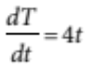. Substituting t = 4 into this equation, we get 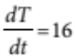.
∴ A [1 mark]
Part B
1 a f(2) = 10(2)² + 3(2) + 1 = 47 [1 mark]
b f(2 + h) = 10(2 + h)² + 3(2 + h) + 1
= 10(4 + 4h + h²) + 6 + 3h + 1
= 40 + 40h + 10h² + 6 + 3h + 1
= 10h² + 43h + 47 [1 mark]
c 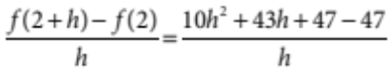
= 10h + 3 [1 mark]
d 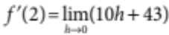
= 43 [1 mark]

2 P(x, y) and Q(x + h, y + k) are two points on the curve with equation f(x) = 11x².
a 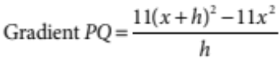 [1 mark]
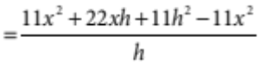
= 22x + 11h [1 mark]
b Gradient of tangent at P 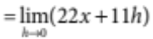
= 22x [1 mark]
3 a h = 3(3)²
= 27 m [1 mark]
b v = 6t [1 mark]
= 6(3)
= 18 m/sec [1 mark]
4 a f ʹ(x) = 12(x)⁵
f ʹ(3) = 12(3)⁵ = 2916 [1 mark]
b f ʹ(x) = 12(x)⁵
12(x)⁵ = −3 [1 mark]
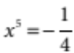
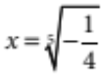 [1 mark]
5 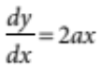 [1 mark]
1 = 4a
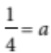 [1 mark]
6 v(t) = 4t²
1 = 4t²
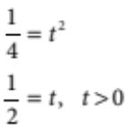

a(t) = 8t
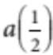 = 8 ×
= 4 m²/s [1 mark]

Part C
1 a C(5) = 0.6(5)² = $150 000 [1 mark]
b 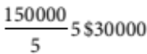, the average cost of airing the first 5 commercials. [1 mark]
c C ʹ(x) = 1.2x
C ʹ(5) = 1.2(5) = 6
∴ marginal cost = $60 000
2 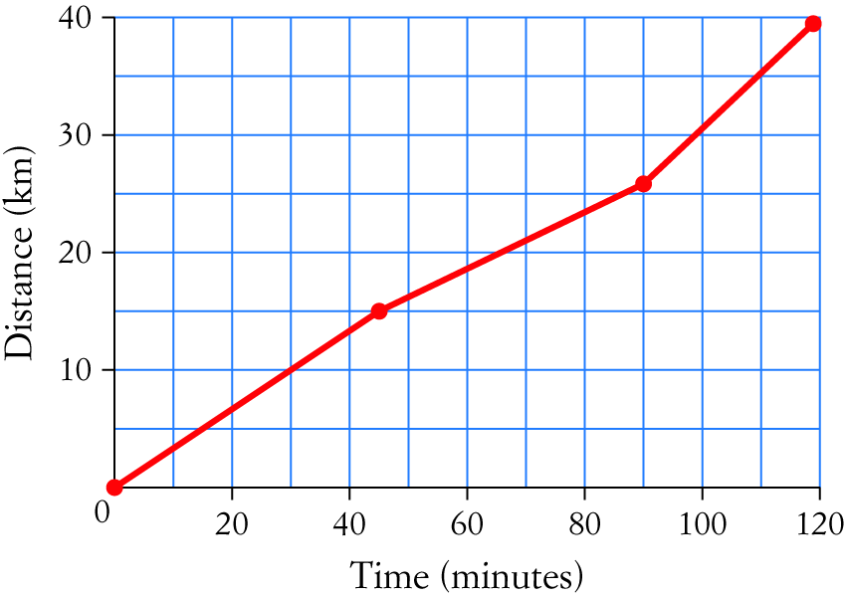
[4 marks]

